Lab Report 4: Humidity

Lilo Heinrich

**Introduction**

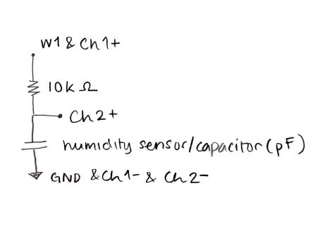In this lab, I built an RC circuit to measure the voltage across a humidity sensor whose capacitance changes with the percentage relative humidity. To extrapolate a calibration curve for my circuit, I replaced the humidity sensor with other capacitors that have a capacitance within the humidity sensor’s typical response range, in order to later be able to convert back from a voltage into a capacitance and then into relative humidity.

**Evidence**

Here is my circuit layout diagram:

The following table is the data collected for the calibration curve of the RC measurement circuit with a 10kΩ resistor, and a 500mV amplitude square wave input with a 500mV DC offset.

|  |  |  |  |  |  |
| --- | --- | --- | --- | --- | --- |
| Capacitance (pF) | 100 | 120 | 150 | 180 | 220 |
| RMS (Ṽ) | 0.4834 | 0.4817 | 0.4785 | 0.4755 | 0.4713 |

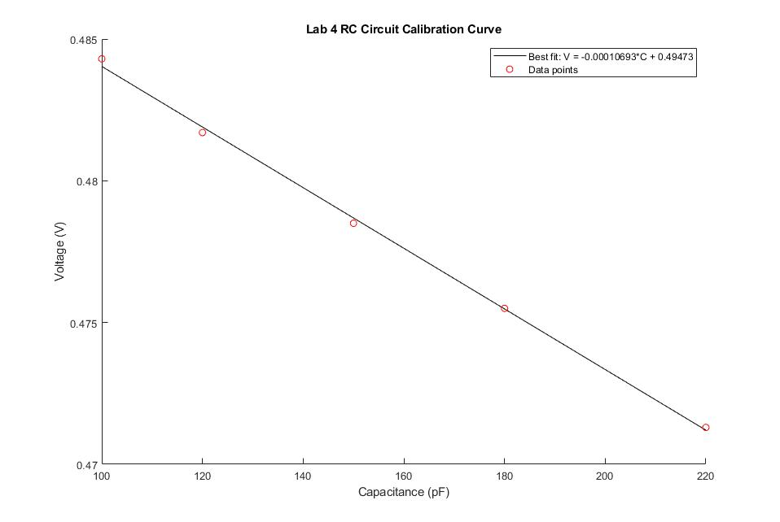

Ṽ-RMS means the root mean square of an alternating current voltage. It can be defined as the square root of the arithmetic mean of the squares of the values, or the square of the function that defines the continuous waveform.

If V(t) is the measured voltage across the capacitor in this circuit at time t, then the root mean square is:

$$RMS= \sqrt{\frac{\sum_{0}^{t}{{V(t)}^{2}}}{t}}$$

My data for the actual humidity sensor is as following:

Humidity sensor RMS: 0.4757 Ṽ

Humidity sensor RMS (when breathing on it): 0.4743 Ṽ

Today, on 9.29.2019 at 3pm in Needham, MA, www.weather.com shows the relative humidity to be 40%.

Lastly, here is my screenshot of Waveforms while using the humidity sensor:

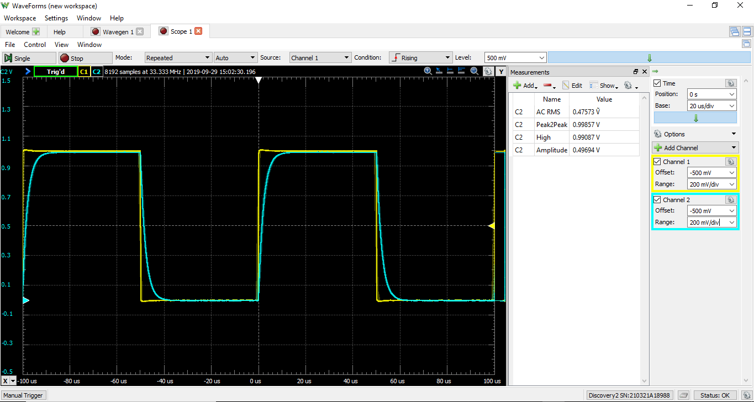

**Analysis and Interpretation**

Plotting Ṽ-RMS by Capacitance, the calibration curve linear best fit line equation is as follows:

$$1. V= -0.00010693 C+0.49473$$

Using the same equation but rearranging to solve for capacitance:

$$2. C = 4626.67 - 9351.91 V$$

Additionally, the equation relating the humidity sensor’s capacitance to percentage relative humidity is:

$$3. RH(X)= -3465.6 X^3 + 10732 X^2 - 10457 X + 3245.9$$

Replacing X with [C(read) / C@55%RH], which is equal to C / 180 according to the datasheet:

$$4. RH\left(C\right)= -0.000594239 C^3 + 0.331235 C^2 - 58.0944 C + 3245.9$$

Solving for the % RH in the ISIM classroom, $RH\left(C(V=0.4757)\right)=RH\left(177.966\right)=48.47\%$

This generally makes sense, since the outside humidity is approximately 40%.

When I breathed on the sensor: $RH\left(C(V=0.4743)\right)=RH\left(191.059\right)=93.27\%$

This also make sense because a person’s breath would be more humid.

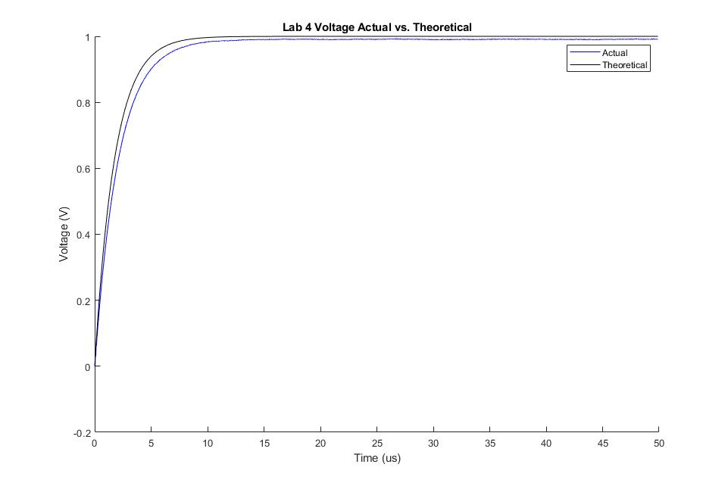

Lastly, comparing the actual collected data of the voltage across the capacitor from the circuit to the theoretical voltage using the equation for a charging RC circuit:

$$Vout=Vin*(1-e^{-\frac{t}{RC}})$$

I plugged in R = 10000Ω, Vin = 1V, and since the humidity of the room is measured as 48.47%, converting that back into capacitance in pF, C = 177.966 pF. The graph shows that the data and the theoretical voltage match fairly well, both following the same shape.

**Error**

This circuit measures voltage, which must be converted back into capacitance, and then into relative humidity. In both conversion steps, there is room for error. Since I am measuring the relationship between Voltage and Capacitance myself, using other capacitors, there could be rounding problems, or the tolerance on the capacitors that I am using for calibration could be significant.

Lastly, since I measured the humidity indoors, in an air-conditioned room, the reading may not be the same as outdoors. This invalidates the only data for comparison that I have, meaning that I can’t accurately calculate the sensitivity of my humidity sensor.